Team of Me

Overview:
Team of Me is a FPS in which you are everyone one on your team. The game is not too unlike Duke Nukem 3D, in which the main character will be a badass who complements himself and is the man’s man every man wants to be. However, the differentiator is that when you are hit, you start the game from the beginning, but another ‘you’ will be playing and doing everything you did from your last life. This will allow the player to essentially play co-op with himself and progress past the initial point of death.

Goal:
Players will use their initial 10 lives to reach the boss encounter.

The Team:
Dying – The player will only have one hit before they are dead. When this happens the player will restart the level from the beginning of the game. Whatever actions the player did during his last life will be recorded and played back when the player comes back to life.
Interacting with the past life – The player will not be able to do anything physical with the past life of himself this includes healing it, trading weapons, or running into it. However, the player character will make comments about how good his past life is doing and looks.
Death of the past life – The past life will do everything the player did including die when the player did. When this happens the past life will fade out and the current life will comment upon it.
Lives – The player should initially get 10 lives in order to complete the objective. This will force the player to play smartly as well as to encourage exploration for extra lives and alternate safer ways to get to the boss encounter.

Environment:
Exploration – The level will be randomly generated based upon an algorithm. Within the level there will be tons of secret routes the player will be able to take allowing the player to bypass sections of the map. In addition to finding these shortcuts there will also be random items and weapons for the player to use.
Secret Areas – Secret areas will visually sick out from the rest of the wall. This will allow players to easily spot where someplace they may want to check out is located. However, some secret areas will be more hidden the others. These harder to find areas will contain better items or better shortcuts.
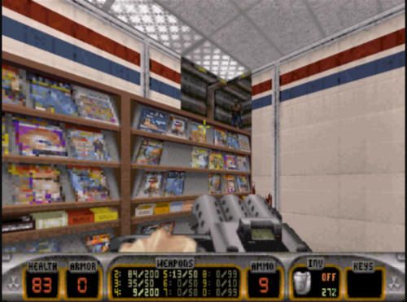
The Map –The player will be able to press the ‘Tab’ key to see the entire map from the beginning. This will allow the player to try and guess where hidden areas may be, as well as find shortcuts through the level.
Items:
Power Ups – The player will find power ups throughout the level hidden within secret areas as well as dropped from enemies. These power ups will give distinct advantages to the player. They will also be used only when the player presses the use button.
Ego Boost – The player will find an Ego Boost Item such as a Frisbee with the player character’s face on it. When this happens the player will gain the ability to shoot and reload faster.
Styling Shoes – Occasionally the player will come up upon some fancy shoes. These shoes will allow the player to run faster for a short amount of time.
Extreme Complement – The player will find a note lying around. When the player finds it the player character will read out a complement some fan wrote to him. This complement will give the player an extra life.
Snazzy Shirt – Finding a Snazzy Shirt will allow the player to be undamaged by enemies for a short while.
Weapons:
The player will be able to use all the different kinds of weapons normally found in a standard FPS. However, the player will initially only has a pistol to use. It is up to the player to search out and find new weapons located around the map. Once acquired, the weapon will be available for use during every life after its acquisition.
Enemies:
Basic Enemies – The player will constantly be bombarded with zombie enemies to fight off. These zombies will grow in speed and cunning as the player progresses through the game. Certain zombies will be carrying special weapons, ammo, or keycards that will allow the player to progress through the level.
Boss Encounter – The end boss that the player will have to overcome will be a puzzle to turn on a piece of equipment. While the player is trying to solve the puzzle waves of zombies will attack forcing the player to defend himself while also focusing upon the puzzles solution.

The Player’s voice
The persona of the player character should be that of someone arrogant. The persona should complement himself as he goes through the game as well as spout many one liners. This persona needs to convey to the player that what the player is doing is awesome as well as manly. A great reference for this character would be Duke Nukem from Duke Nukem 3D.

FPS – Horror – Pride – No Hitpoints – Casual Explorer
Demographic:
Casual Explorer – A player who is considered a casual explorer would most likely want to try and find all the hidden secret areas within a level. By definition Team of Me adheres to what these players want most in their game through encouraging exploration through rewards. However, a game without hitpoints may discourage casual players from coming back. To combat that, the lives mechanic is in place to reward players after death as well as show them how awesome they played, even though they died.

Final Life:
Casual Explorers will enjoy coming back to Team of Me through its prideful charm as well as for the explorative nature of the game. Since no level is the same casual explorers will always have somewhere new to explore. They will never know what is behind the next secret wall or if the weapon they love will be just hidden out of reach in the beginning of the game.

