Fractured Alliance
Overview:
Fractured Alliance is a 16 player first person shooter for the PC. It is set in a futuristic setting akin to Red Faction; however, Fractured Alliance uses a dynamic team management system that will allow players to switch teams on the fly. This feature will help sow deceit into the fabric of factions causing players to create hidden allegiances, infiltrate and sabotage factions, organize chaos, and much more.

Goal:
The players of Fractured Alliance are each trying to be on the team that conquers all four fortresses.

Dynamic Factions:
Factions:
Unionized Factions – There are four unionized factions, the Crimson Faction, Azule, The Vipers, and Ra’s Disciples, located on each corner of the map and each unionized faction will start the game with three members. However, one member will start the game as the Faction Head and the head must remain on the union until the faction is destroyed.
The Free Faction – The Free Faction members share no fortress or inherent allegiance to any faction or member, including others on The Free Faction. They are allowed to kill any member of any faction in the game and capture any fortress. Respawning for them means respawning randomly in the middle of the map unless they have captured a corner fortress then normal respawning rules apply.
Control – Unionized factions start out with a max of three members. When a fortress is destroyed, for the first time, every faction gains a new control point which allows for an additional member on the faction. If a faction captures a fortress, that faction gains an additional control point. If a faction loses a fortress, they lose their additional control point gained from it and the last member to join the faction is kicked out if they are over their control limit. The Free Faction has no limit on members.
The Contract – Once a member joins a unionized faction they will not be able to kill a teammate. That member will also have access to the faction’s fortress (more on fortresses below) and a faction-com option will also be accessible through VOIP and text.
Spawning – Members will either respawn in their base’s incubator (explained in fortresses) or when that option is gone the members will spawn randomly in the center area of the map.
Faction Communication – Members will be able to chat through text or VOIP to all members, their faction, or to a specific member/group. These groups can be created and managed by any member through the group management tooltip.
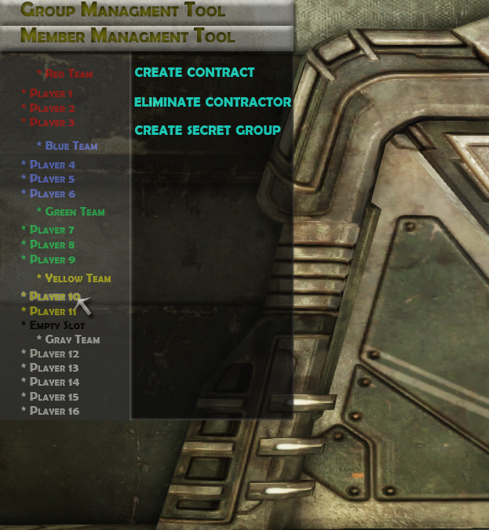
Member Management Tool – This tool allows the member to quickly and effortlessly see who is on what faction and allow the head to manage their faction members. In order to use the collapsible tool, the player must press F1 to toggle the mouse on and off.
Create Contract – Any faction member may invite another member to their faction. However, these invites must be done face to face and through the Member Management Tool. The invitation will last until the member either accepts or declines it. If killed with an open request the member will drop a particle effect in the color of the invitation’s faction for all to see.
Dissolving Contracts – Members can switch factions at any time, as long as they are invited. Members can also leave a faction at any time and join The Free Faction. When they do either of these options they lose all privileges of being on their previous faction.
Eliminate Contractor – Faction Heads will be able to eliminate contracted members from their team at any time and for any reason.
Create Secret Group – Through this option, members will be able to create secret groups that can be managed through the Group Management Tool. Only the members in the group will know of it.
Group Management Tool – This tool will allow members to select the groups they want to talk to, leave groups, and manage who is in what group.
Fortresses:
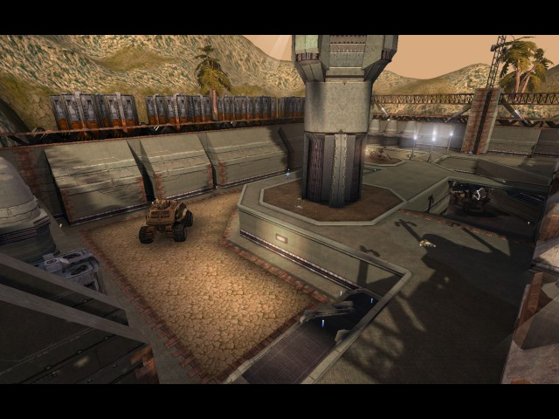
Information Core – Members will have to protect their information core to maintain their team.
Destroying a Core – An information core can only be destroyed by placing and arming a bomb on it. This bomb takes 180 seconds to explode and has to be disarmed, which takes 20 seconds. Once the core is destroyed that faction dissolves, unless they have another base, and those members join The Free Faction.
Warning Zones – When any member of any faction is in this 20 yard zone around a faction’s information core for over five seconds an alarm will sound and all members of that faction will be notified of the intruder.
Capturing a Fortress – After a core has been destroyed a faction can rebuild it and capture the base for themselves by rebuilding the core. Rebuilding the base requires 180 seconds of maintenance (i.e. any member standing in the base). A timer will appear on the screen for everyone in the game denoting how much time is left until the base is rebuilt. If a member leaves the base and another member enters, from any faction, the countdown will continue from where it left off. After the timer finishes the fortress goes to the last remaining faction in the base (even if that faction rolls in and destroys everyone else).

Defenses – Members can use defenses in their base to help defend their information core from other factions. However, all the defenses can be destroyed by any faction by either shooting them or by sabotage.
Turrets – Members can man turrets to defend the core. These turrets can attack outdoors and do moderate damage to both vehicles and members.
Doors – Doors will block entrance to everyone but the faction that owns the fortress.
Incubators – These pods will respawn members every 20 seconds.
Vehicle Depot – The Base initially holds a Humvee. When a member finds a new vehicle on the map and brings it back to the depot it will then also spawn that vehicle for all controlled fortresses.
Weapon Depot – Bases start off with ammo for shotguns and pistol. When a member finds a new weapon on the map and brings it back to the depot it will then spawn that weapon for all controlled fortresses.
Sabotage – Members will be able to sabotage defenses of any faction to different degrees based upon how long they stay sabotaging the defense. In order to, the player must press F1 to gain access to their mouse. After that they must stand next to the defense and right click on it to initiate the sabotage. The different levels of sabotage in increasing order are malfunction (the defense will not work), overheat (the defense will overheat and blow up in a few seconds), and accident (the defense will explode upon next use).
Rebuilding – Once a defense is destroyed a member can repair it by standing next to it for 90 seconds (does not have to be consecutive, the timer will continue from where it left off if a member walks away).
Repairing – In order to repair defenses, the defense must not have been shot for at least 60 seconds and a member has to be standing next to it. Once the defense is shot, the repairs are stopped.

Under The Veil:
Deceit, players will have to deal with this concept. Not because it is programed into the game, but because it is programed into the people playing the game. How players deal with deceit will vary upon circumstances as well as depend upon the player, causing unique gameplay experiences for every game.

